26.28: Given that the full-scale deflection current is 500 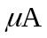 and the coil resistance is 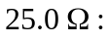
a) For a 20-mA ammeter, the two resistances are in parallel:

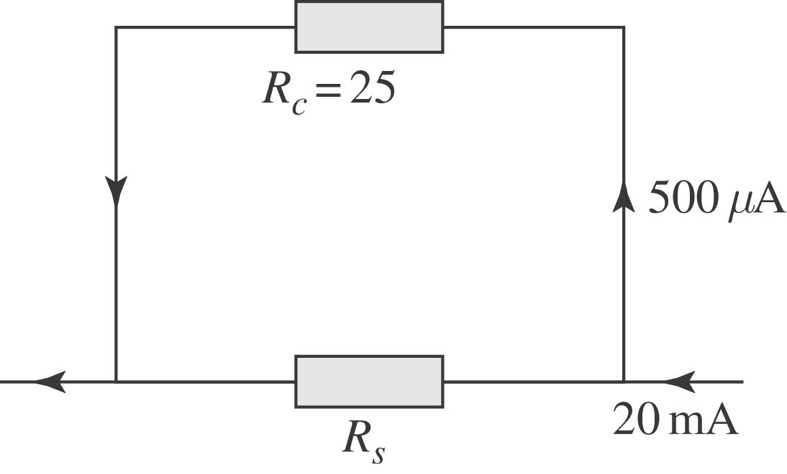

b) For a 500-m voltmeter, the resistances are in series:
